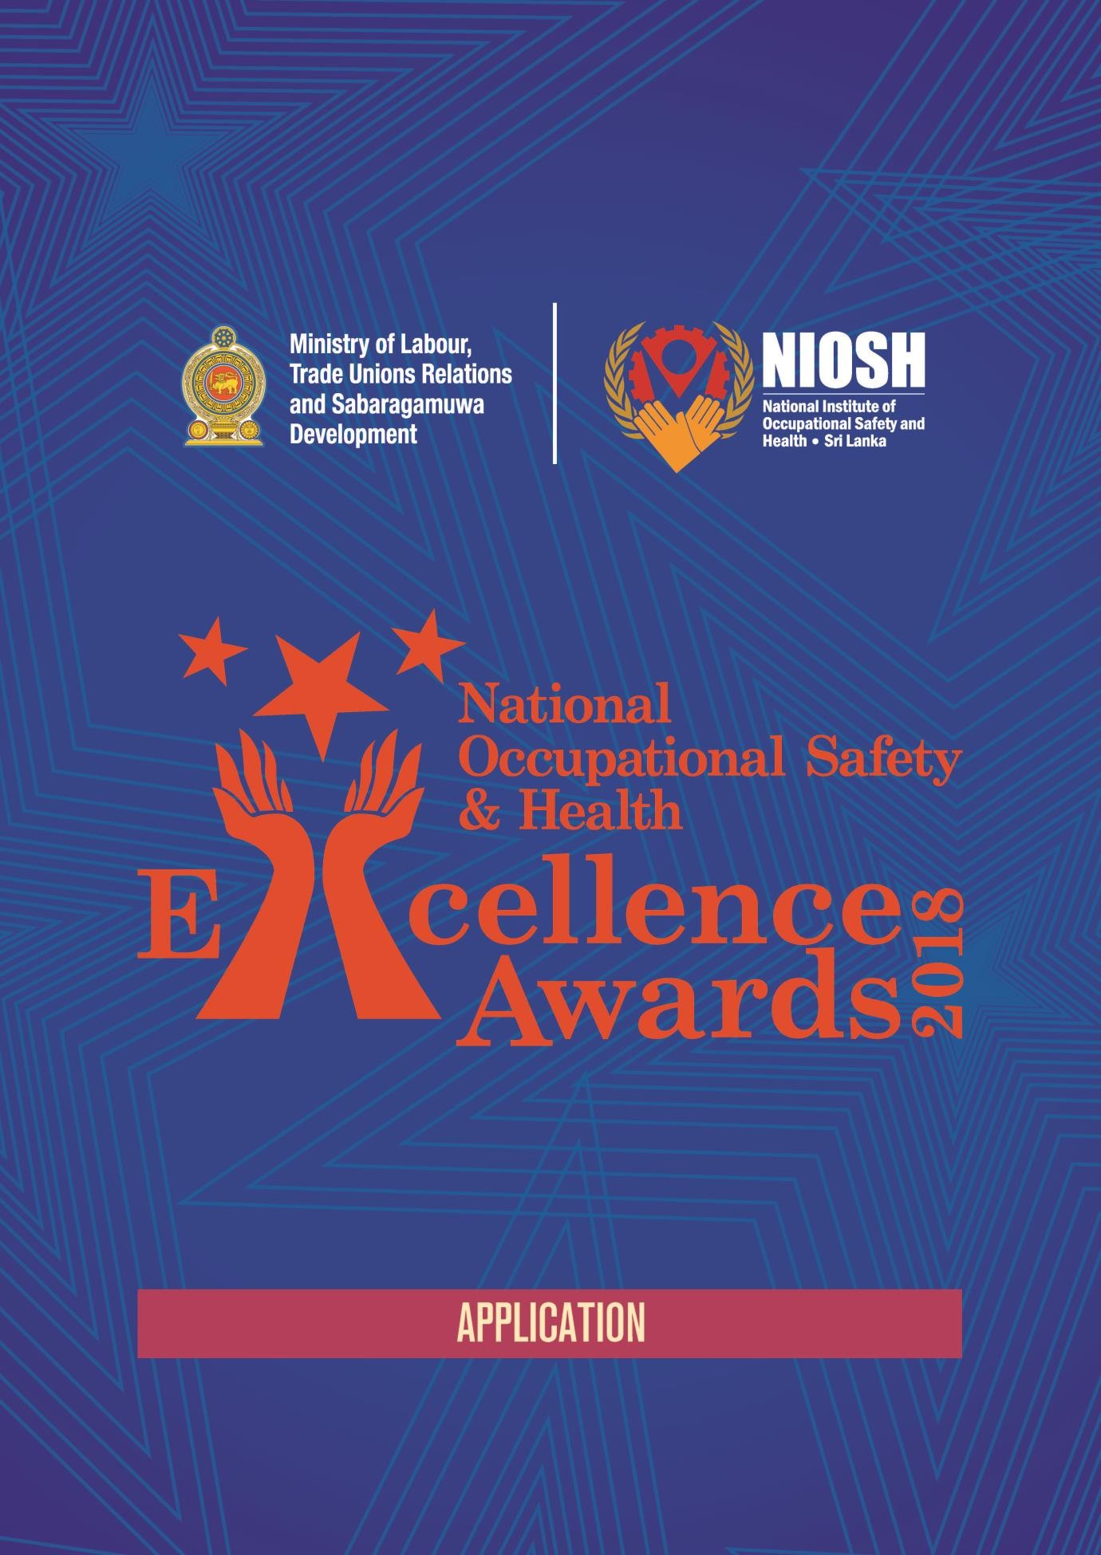

Section A
A-1.0 PROFILE OF COMPETING LOCATION (Branch or Factory)

1.1 Name of the Organization: ……………………………………………………….......
Address ofcompetinglocation: …………………………………………………....
……………………………………………………
……………………………………………………
Category: Local (Business originated in Sri Lanka)/Multi-national

Industrial Sectors (Please tick one appropriate box) 1.4.1Tourism, hotel & restaurant and related services 1.4.2Manufacturing

Construction
Transport &Logistics 1.4.5Apparel andTextile
1.4.6 Food and Beverage 1.4.7Agriculture
1.4.8 Other, Please Specify……………………………………………………………..
No. of employees:Permanent: …………… Contracted employees:…………….

A- 2.0 Contact Person/ Safety Coordinator
2.1 Name:………………………………………………………………………………….
2.2 Designation:…………………………………………………………………………...
2.3 Telephone No:
Office:…………………… Mobile:……………………..
2.4 Fax No: ………………………
2.5 E-mail address: …………………………

A- 3.0 Operational Background
3.1 Main Operation:………………………………………………………………………..
……………………………………………………………………….
Brief account of sub activities /processes*:
……………………………………………………………………………………………….
……………………………………………………………………………………………….
……………………………………………………………………………………………….
Outsourced** activities / work carried out at the competinglocation:
……………………………………………………………………………………………….
……………………………………………………………………………………………….
* Please attach a processflowdiagram ** Work carried out at the competing location by contractualemployees.

Initial date of commencement of operations at the competinglocation:
…………………….(DD/MM/YYYY)

Are any employees working inshift basis: (Yes/No)
If yes;
No. ofshifts:……….. No. of hours per shift:…………….

Amount of budget allocation for OS&H for the year 2021 LKR…………………………
The above amount of budget allocation as a percentage from total budgetin 2021 %
Expenditure for OSH in2020:LKR (Please attachevidences)
Expenditure for OSH in2019:LKR (Please attachevidences)

Section B

All the evidences and records should be produced within the period of 1st of January 2019 to 15th of March 2021.

B-1.0 Management Commitment and Line Accountability
Describe the approaches towards ensuring safety culture by your top management?......................
……………………………………………………………………………………………………..

Does your organization have a written safety and health policy?Yes/No

B.1.1.2. If yes, please attach a copy of your safety and healthpolicy.

B.1.1.3. What are the methodologies used to communicate the safety and health policy with
stakeholders? (Please attachevidences)

…………………………………………………………………………………………..
…………………………………………………………………………………………..
…………………………………………………………………………………………..
…………………………………………………………………………………………..
…………………………………………………………………………………………..
…………………………………………………………………………………………..
B.1.1.4 Explain the top management involvement and commitment to prevent and combat COVID-19 ……
……………………………………………………………………………………………….
……………………………………………………………………………………………….
………………………………………………………………………………………………. (Please attachevidences)
B.1.1.5 Describe COVID-19 preventive strategies (eg: COVID-19 Policies, Business Continuity Plans etc.) ……
……………………………………………………………………………………………….
……………………………………………………………………………………………….
………………………………………………………………………………………………. (Please attachevidences)

Is there any designated person appointed as a responsible person for Safety Management? Yes/No

If yes, what are the qualifications / experience of the above person? (Please attach evidences)

…………………………………………………………………………………………..
…………………………………………………………………………………………..

Are there Safety Committees functioning in your organization?Yes/No
If yes, please provide names of the committee members and designations of such members.
…………………………………………………………………………………………..
…………………………………………………………………………………………..
…………………………………………………………………………………………..
…………………………………………………………………………………………..
…………………………………………………………………………………………..
…………………………………………………………………………………………..
…………………………………………………………………………………………..
…………………………………………………………………………………………..
…………………………………………………………………………………………..

If yes, attach last three committee meetingminutes.

Do you have job/position descriptions for all employees including safety responsibilities? Yes/No

If yes, attach Job descriptions of one senior management role, one executive role, person responsible for safety and one operations or maintenance relatedworker.

What are the engagement and interaction activities of Senior Leaders in your organization on Safety and Health with the shop floor workers.(Please attach evidences of eachpractice)

…………………………………………………………………………………………..
…………………………………………………………………………………………..
…………………………………………………………………………………………..
…………………………………………………………………………………………..
…………………………………………………………………………………………..
…………………………………………………………………………………………..
…………………………………………………………………………………………..
…………………………………………………………………………………………..
…………………………………………………………………………………………..

Do you have reward, recognition and/or consequence management programs with related to OS&H? Yes/No

If yes, attach evidences or procedures that related to reward, recognition and/or consequencemanagement.

What are the methods that your top management engage with Proactive safety related practices.(Please attach evidences of eachpractice)
…………………………………………………………………………………………..
…………………………………………………………………………………………..
…………………………………………………………………………………………..
…………………………………………………………………………………………..
…………………………………………………………………………………………..
…………………………………………………………………………………………..
…………………………………………………………………………………………..
…………………………………………………………………………………………..

B-2.0 Objectives and Planning
How did your organization determine the most significant safety and healthhazards?

…………………………………………………………………………………………..
…………………………………………………………………………………………..
…………………………………………………………………………………………..
…………………………………………………………………………………………..
Provide Risk assessment procedures and Sample Risk assessment. (Please attach evidences)

What are the control measures in place for the most significant 5 hazards at your organization/site.(Please attach evidences of each controlmeasure)

…………………………………………………………………………………………..
…………………………………………………………………………………………..
…………………………………………………………………………………………..
…………………………………………………………………………………………..
…………………………………………………………………………………………..
…………………………………………………………………………………………..

What are the methods that organization used to communicate top 5 risks among all employees in 2019/2020.(Please attach evidences of eachmethod)
…………………………………………………………………………………………..
…………………………………………………………………………………………..
…………………………………………………………………………………………..
…………………………………………………………………………………………..
…………………………………………………………………………………………..
…………………………………………………………………………………………..
What are the occupational safety and health priorities/targets for 2021 based on key risks in theorganization.

…………………………………………………………………………………………..
…………………………………………………………………………………………..
…………………………………………………………………………………………..
…………………………………………………………………………………………..
…………………………………………………………………………………………..
…………………………………………………………………………………………..
…………………………………………………………………………………………..

What is the level of achievement of safety and health objectives of 2020.(Please provide the evidence with actual vs.plan)

…………………………………………………………………………………………..
…………………………………………………………………………………………..
…………………………………………………………………………………………..
…………………………………………………………………………………………..
…………………………………………………………………………………………..
…………………………………………………………………………………………..

Do you have mechanism to integrate individual OS&H related key performance indicators (personal KPIs) with performance appraisal system.Yes/No

If yes, what is the minimum-maximum performance proportion on OS&H individual KPIs min…….…% max %

Attach 2020 performance evaluation completed sheets as evidences on senior management level, executive level, supervisor level and shop floor worker level.(Please highlight health and safetysection)

B-3.0 Legal Obligations, Standards and Procedures
Do you maintain a General Register (Accident Register)?Yes/No
(Please attach photocopies of the pages of the entries made from 01.01.2019 to date)
Is there a system of “Permit to work” in practice?Yes/No
2.1 If yes, attach samples of completedpermits.
How you assess the risk of non-routine activities, such as breakdowns relatedactivities?
…………………………………………………………………………………………..
…………………………………………………………………………………………..
…………………………………………………………………………………………..
…………………………………………………………………………………………..
…………………………………………………………………………………………..
…………………………………………………………………………………………..
…………………………………………………………………………………………..

Please attach the samples of recent non-routine risk assessments (Job safety analysis/job hazards analysis/personal riskassessments)
Are there any confined spaces in your organization?Yes/No
If yes, how do you manage the risks associated with confined space entrywork?
(Please attach a copy of confined space entry procedure)
…………………………………………………………………………………………..
…………………………………………………………………………………………..
…………………………………………………………………………………………..
…………………………………………………………………………………………..
…………………………………………………………………………………………..
…………………………………………………………………………………………..
…………………………………………………………………………………………..

Are there any pressure vessels in your organization?Yes/No
If yes, are the pressure vessels (such as steam boilers, steam receivers, air receivers, gas receivers) periodically examined and certified?Yes/No
(Please attach a copy/copies sample of latest examination reports)
Are persons operating boilers certified to operate in the relevant type & capacity of steam boilers?Yes/No
(Please attach copies of certificates)

Have you registered all your boilers under the industrial safety division of the Labour Department? If yes please attach the registration certificate/s

Are there any lifting appliances in your organization?Yes/No
If yes, attach list of lifting equipment and valid testing certifications for2020.
Do you handle chemicals in your industry?Yes/No
B.3.8.1. If yes, please attach the relevant documents related to control measures taken in handling chemicals?
B.3.8.2 Please attach photographs of chemical storage.
What is the mechanism that organization used to manage industrialwaste?
…………………………………………………………………………………………..
…………………………………………………………………………………………..
…………………………………………………………………………………………..
…………………………………………………………………………………………..
…………………………………………………………………………………………..
…………………………………………………………………………………………..
…………………………………………………………………………………………..

Please attach any certificates/licenses/proof of industrial wastemanagement.
Are the building(s) provided with lightening protection?Yes/No
(If yes, please provide latest test report)
Are electrical installations at the work place certified by the Charted Electrical Engineer annually?Yes/No
(If yes, please provide latest test report)
Do you have competent people to conduct energy isolations?Yes/No
(If yes, please attach proofs of their competency certificates)
Is there a procedure for managing energy isolations?Yes/No
(If yes, please attach the copies of energy isolation procedure and electrical safety procedure)
Does the company follow any specifications for selection of the personal protective equipment? Yes/No
(If yes, please attach specification copies of the personal protective equipment)
How do you manage the risks associated with “Working at Height”activities?
(Please attach a copy of procedure)
Does your organization use full body harnesses during work at height activities?Yes/No
(If yes, please provide training and competency evidences of using full body harnesses)

What are the common hot work activities conducting at your organization? (Welding/cuttingetc)
(Please provide a copy of hot work safety procedure)
…………………………………………………………………………………………..
…………………………………………………………………………………………..
…………………………………………………………………………………………..
…………………………………………………………………………………………..

Do you take services/man power via contracted companies? (Eg: Security, cleaning, non core jobs, core jobs etc.,)Yes/No
If yes, what are the control measures that taken to ensure safety of those workers? Please attach evidences on followingareas:
B.3.18.1 (a) Contractor Safety Management Procedure (Method of contractor selection, control and evaluation, criteria used, Safety related Clauses of Contract agreement etc.,)
B.3.18.1 (b) Safety and Health related contract clauses in general contractor agreement (2 samples)
B.3.18.1 (c) Insurance policies of contractors
B.3.18.1 (d) Contractor workers health assessment reports
B.3.18.1 (e) Any other document relevant to this topic

Are organization use any specific/other standards that relevant to operational requirements or client requirements?Yes/No
If yes, please attach three important standards being used byorganization.

How is the organization managing the risks relevant to routine activities? (Standard operational procedures/workinstructions)
Please attach three sample procedures/workinstructions.

Does the organization have a documents/records controlling procedure?Yes/No
If yes, please attach the copy of theprocedure.

Design and ProcessSafety
Does the organization have design safety guidelines related to electrical, mechanical and process safety? Yes/No
If yes, please provide design safetyguidelines.

Does the organization have a program to ensure the integrity of buildings and constructions? Yes/No
If yes, please provide the recent structural integrity assessmentreport.

Is organization following a management of change (MOC) process before any safety related changes?Yes/No
If yes, please provide two samples of recent management of changedocuments.

Does the organization have a plan to ensure the availability of critical safety equipment via preventive maintenance program?Yes/No
If yes, please provide the last 6 months preventive maintenance plan vs. actual performancedetails.

How does organization ensure design safety guidelines, management of change process, are considered during the purchasing process.(Please provide anyevidences)

Skills, Competencies andCommunication
What are the safety and health training programs have your directors, managers and supervisors undergone during last 12 months? (Please provide anyevidences)

Does the organization have health and safety training plan for year 2021?Yes/No
If yes, please provide the evidence of 2021 trainingplan.
Please provide the evidences of 2020 training plan vs. actual completionrecords.

Have you conducted a training need analysis for all job positions in preparation of training plan?Yes/No
If yes, please provide one sample of training need analysis from each category of top management, senior management, supervisory level, operator level, safety responsibleperson.

What are training evaluation methodologies to ensure the effectiveness of training? (Please provide proof for eachmethodology)

How organization ensure/verify the trainer qualifications before delivering thetraining?
(Please provide proof for ensuring trainer qualifications)

What are the specialized skills that certified by external bodies to carry out activities at your organization? (eg: Forklift Operator, Crane Operator, Welder, Scaffolding Erector etc.) (Please provide evidence of each specialized skillsactivity)
How to ensure the competencies of your contracted employees who are delivering routine and non-routine tasks? (Please provide proof for ensuring the competencies of contractedemployees)

Do you have behavioral based safety program implemented in your organization?Yes/No
If yes, please provide the evidences of the recent behavioral based safetyprogram.
What are the health and safety related communication methodologies that used to enhance safety culture within the organization? (eg: Toolbox talks, Safety pause, Safety meetings, informal safety communication practices etc.) (Please provide proof for health and safety related communication methodologies)
What are the communication techniques you used to enhance knowledge on COVID-19 prevention among your workforce? (please attach relevant evidences)
Do you use safety signage practice within your organization?Yes/No
If yes, please provide photo evidences for mandatory, warning, information and prohibitionsignages.

Health, Hygiene andWellbeing
Do you conduct periodic health checkups for employees?Yes/No

Do you conduct analysis using the available reports?Yes/No

If yes, please attach analysis report or key findings of the medicalsurveillances.

Do you carry our health impact assessment based on the operation?Yes/No

If yes, please attach a copy of assessmentreport.

B.6.4 Describe COVID-19 controls implemented at your entity ……………………………………………………………………………………………….
……………………………………………………………………………………………….
………………………………………………………………………………………………. (Please attachevidences)

Have you conducted an ergonomic assessment for all routine tasks and repetitive activities? Yes/No

If yes, please attach theevidences.

What are the control measures that you use to manage the workplace stress and stress related health issues.(Please provide proof for managing the workplace stress and related healthissues)

Do you have a policy for sickness absence and rehabilitation of post injured employees? Yes/No

If yes, please provideevidences.

Have your organization conduct wellbeing assessment?Yes/No

If yes, please attach theevidences.

What are the health improvement programs for employees promoting by your organizations within year 2020 and plan for 2021? (Please provide evidences of 2020 health improvement programs and plan for 2021)

Audit, Assessment andMonitoring
Are you conducting health and safety related internal audits?Yes/No

B.7.1.1. If yes, please provide the audit plan and two recent internal audit reports.
B.7.1.2 What is your internal auditing criteria?

What are the qualifications of the internal auditors, who conducts the internalaudit?
(Please attach relevant evidences)

Are you conducting health and safety related external audits?Yes/No

If yes, please provide the external audit plan and one recent external auditreport.

Have you conducted any specific risk related audits? (eg: Working at height, Electrical Safety, Vehicle safety, etc)Yes/No

If yes, please attach one latest auditreport.

What are the proactive safety practices implemented in your organization? (Safetywalk, safety observation tours, task observations, planned inspections etc,.) (Please attach relevant evidences)

Do you have equipment testing and inspection procedure for portable and fixed power tools?Yes/No.

If yes, please provide three different types of inspectionrecords.

Do you conduct workplace exposure monitoring? (Dust/emissions/air quality /noise/heat
/illumination etc.) Yes/No

If yes, please attach latest copies of each type ofreport.

How you ensure all critical safety devices are properly calibrated as per OEM recommendations (Multi-gas analyzers, pressure gauges, etc.,) (Please attach relevantevidences)

…………………………………………………………………………………………..
…………………………………………………………………………………………..
…………………………………………………………………………………………..
…………………………………………………………………………………………..

Do you have fire detection and suppression system in place at your organizations?Yes/No

If yes, provide technical drawing that covers critical operational areas including people safety and machinesafety.

How do you conduct fire system inspection, testing and maintenance to maintain system reliability?

…………………………………………………………………………………………..
…………………………………………………………………………………………..
…………………………………………………………………………………………..
…………………………………………………………………………………………..
…………………………………………………………………………………………..
…………………………………………………………………………………………..
…………………………………………………………………………………………..
…………………………………………………………………………………………..

Please provide evidences of fire system inspection, testing and maintenancerecords.

Do you conduct legal compliance audits for your operational scope as per local legal requirements?Yes/No

B.7.11.1. If yes, please provide latest legal compliance audit report.

Do you conduct employee engagement, perception survey for health and safety?Yes/No

If yes, please provide latest health and safety surveyreport.

Do you conduct management reviews related to health and safety?Yes/No

If yes, please provide the minutes of latest health and safety managementreview.

Emergency Preparedness, Reporting and Improvements
Do you have a person(s) trained in first-aid at your workplace?Yes/No

If yes, please attach copies of trainingcertificates.

Do you have a medical center operated by trained medical staff?Yes/No

If yes, please attach copies of training certificates and a photo of your medicalcenter.

Do you have trained emergency response team?Yes/No

If yes, attach the list of names, qualifications and designations of the teammembers.

Do you have emergency response plan?Yes/No

If yes, please attach copy of emergency responseplan.
Describe your emergency response plan in case of detection of a COVID-19 patient in your premises. (attach relevant evidences)

What are the Emergency response equipment and facilities that available at site based on the aboveplan?

…………………………………………………………………………………………..
…………………………………………………………………………………………..
…………………………………………………………………………………………..
…………………………………………………………………………………………..
…………………………………………………………………………………………..
…………………………………………………………………………………………..
…………………………………………………………………………………………..

Do you conduct emergency mock drills?Yes/No

If yes, please provide mock drill reports. If you have mock drill plan, pleaseprovide.

Is there a designated person in charge of fireprotection?

If yes, state name anddesignation………………………………………………..……..

(Please provide copies of certificates regarding training &experience)

Provide following health and safetydata.

 | 2016 | 2017 | 2018 | 2019 | 2020
No of Employees (Own)
No of Employees (Contract)
No of Reportable fatalities
No of Reportable major injuries
No of Reportable over 3-day injuries
No of Reportable diseases
No of Critical incidences (Dangerous Occurrences)
No of Work related road injuries and fatalities
No. of vehicle accidents

Does the organization conduct any safety data analyzing, trend analysis on health and safety statistics?Yes/No

If yes, please provide data analysis and three critical observations based on your trend analysis. (specific focusareas)

Do you have incident reporting and investigation procedure?Yes/No

If yes, please provide the evidence of procedure and sample incident investigation report.

Provide the evidence of feedback and remediation agreed on above mentioned incident investigationreport.

Explain how your organization guarantees the investigation of occupational health and safety issues ensuring the implementation of the lessons learnt. (Please provideevidences)

Do you have hazard reporting (unsafe conditions/unsafe acts) mechanism?Yes/No.

If yes, please provide sample hazard report from each category of employees (Senior Management/Executives/Supervisory level/Operatorlevel)

Section C
Do you have internal safety recognition program?Yes/No

If yes, please provide evidence of 2020 safetyrecognitions.

Have you implemented a safety management system in your organization? Yes/NO
If Yes, specify with proof
Have you certified your organization with National Occupational Safety and Health Management System (NOSH-MS)?

What are the external recognitions related to health and safety performance of your organization? (Please provideevidences)

What are the top three safety related innovations during last two years.(Please provide evidences)

What are the Health and Safety related CSR activities in your organizations? (Please provide evidences)

Please provide the evidences top management involvement in critical safety related incident investigations in last 5 yearsperiod.

How often your CEO/Managing Director visiting your business location in focus of safety improvements?
……………………….. (Please provide the frequency)

Please provide last two reports/advises or any other evidences to provehis/her involvement in health and safety atfield.

Declaration

I declare that there:
- Have been / not been* accidents resulting fatality.
- Have been / not been* accidents resulting in permanent totaldisability.
- Have been / not been* accidents resulting in permanent partialdisability.
- Have been / not been* incidents resulting property damage worth of LKR 5 million due to safety relatedincident
within premises/outside premises* but involving persons responsible under control of our organization, during the period 01/01/2019 to date.
(* Delete as appropriate)

I certify the correctness of the information provided in this document.

……………………………..
Date

……………………………………..
Name & Signature (Person Responsible for OSH) (Include Signature stamp)

……………………………..
Date
……………………………………..
Name & Signature (CEO / MD / Board Member) (Include Signature stamp)

